**Git Assignment**

**Assignment 1: Initialize a new Git repository in a directory of your choice. Add a simple text file to the repository and make the first commit.**

**Initialize a new Git Repository:**

**Step 1:** Firstly we need to create an account in [GitHub](https://github.com/). After that we need to create a new Repository with a name in the GitHub where all the files be stored.

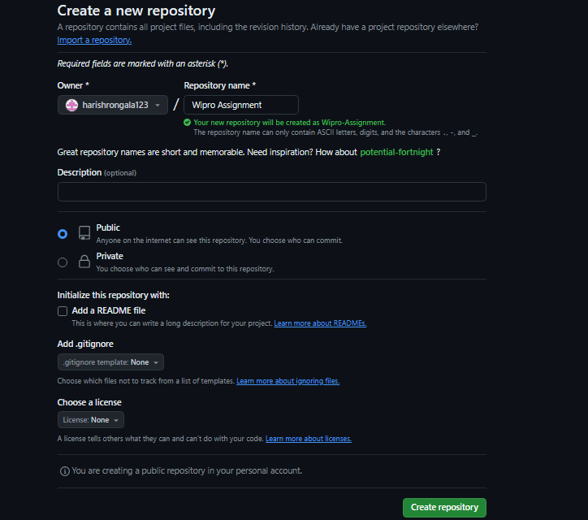

**Step 2:**

Make Sure we have Git installed in the PC. Go to the file which we need to add in the repository and open the git Bash or command prompt with the same address.

**Step 3:**

In the Command prompt use **"git init"** command to initialize the Local Repository

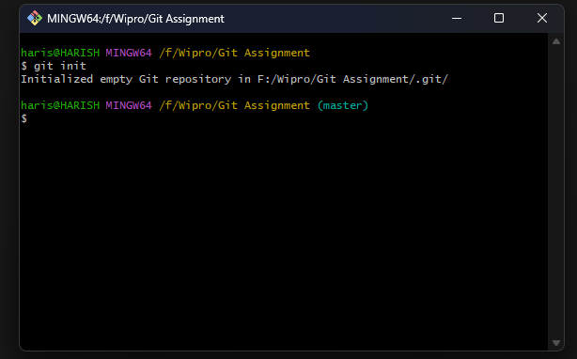

**Step 4:**

To add all the files in the local repository we use **"git add ."** command. Here dot represents all the files. "git status" command is used to show the status of the local repository.

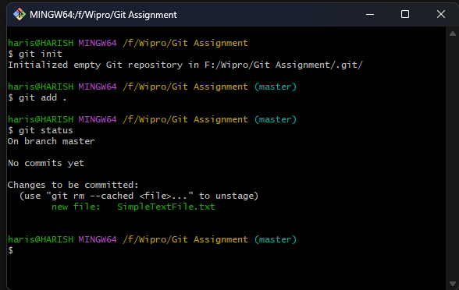

**Step 5:**

Commit the added file using **"git commit -m"**

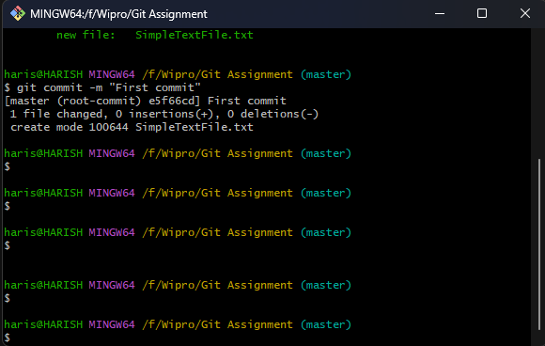

**Step 6:**

Use "git push origin master" command to push all the files which are committed in the GitHub repository

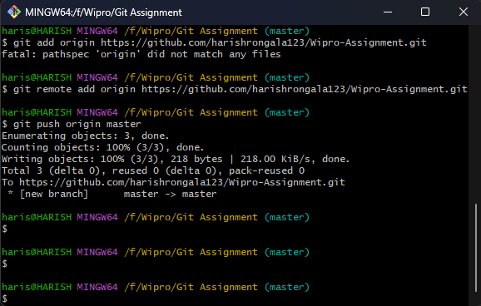

**Step 7:**

We can see the file added in the GitHub

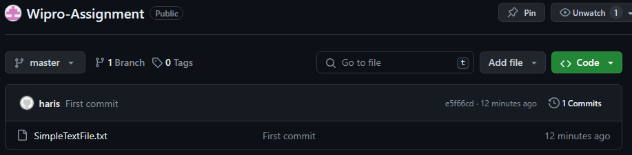

**Assignment 2:** **Branch Creation and Switching**

**Create a new branch named 'feature' and switch to it. Make changes in the 'feature' branch and commit them**

**Step 1:**

Create a new branch named **"feature"** in the local repository using **"git checkout -b feature".**

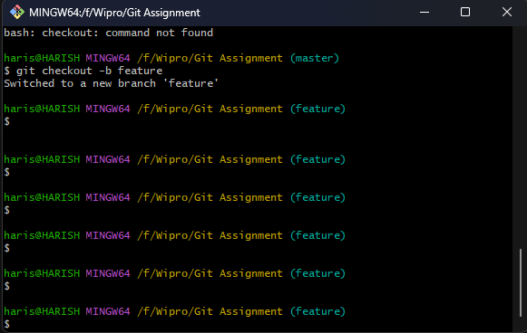

**Step 2**:

Add a file in the feature branch

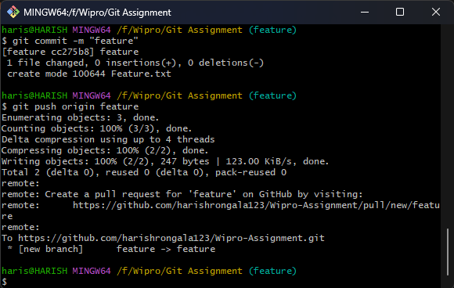

**Step 3:**

In the feature branch we can see the feature file in it

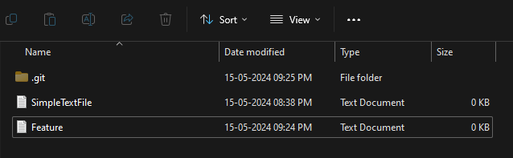

**Step 4:**

Once if we change the branch to feature to master, in the same address the master branch has no feature file, use git checkout master to switch from feature to master.

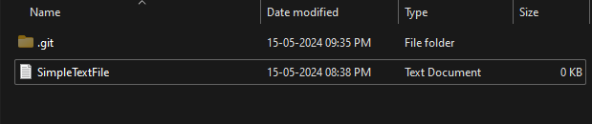

**Assignment 3: Feature Branches and Hotfixes**

**Create a 'hotfix' branch to fix an issue in the main code. Merge the 'hotfix' branch into 'main' ensuring that the issue is resolved.**

**Step 1:**

Create a new branch **"hotfix"** using "**git checkout -b hotfix**" and add file.

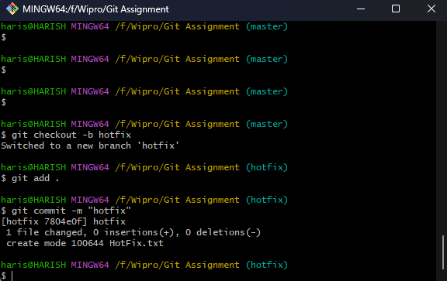

**Step 2:**

Switch from hotfix branch to master branch using "git checkout master" command.

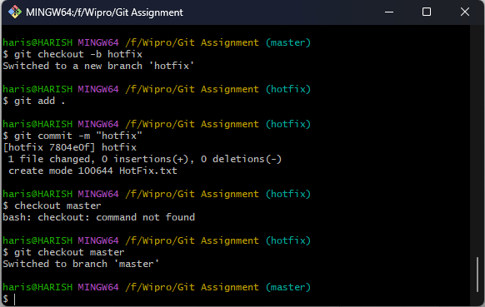

**Step 3:**

Merge the master and all the branches using **"git merge master feature"** after that **"git merge master hotfix".**

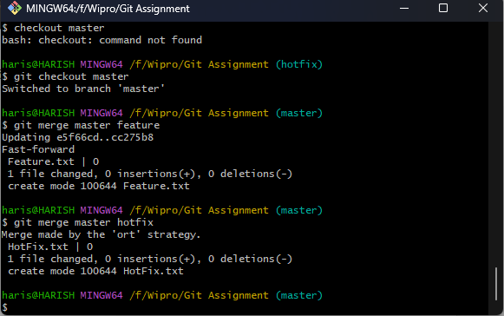

**Step 4:**

Check the files add from hotfix and feature to master

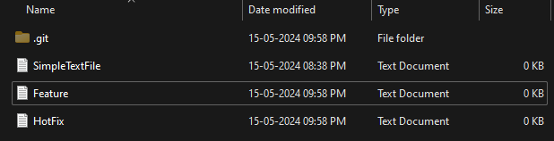

**Step 5:**

But in the github the files are not added to do so we need to pull request.

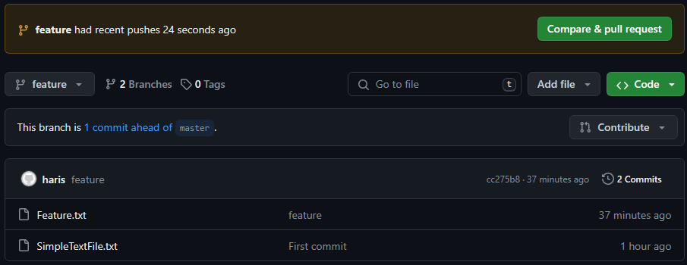

**Step 6:**

After pull request and approved by the github owner the files get added.

